**ASSIGNMENT-5**

U19CS012

**1.** Obtain and Plot the forward and reverse characteristics of ZENER Diode in *LabOnline* Simulation Environment.

A.) Forward Characteristics of ZENER Diode

*1.) Circuit Image:*

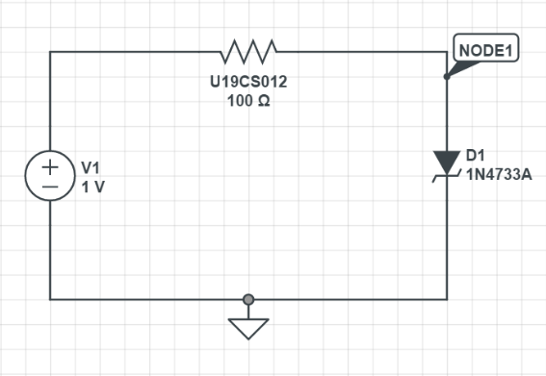

*2.) Graph:*

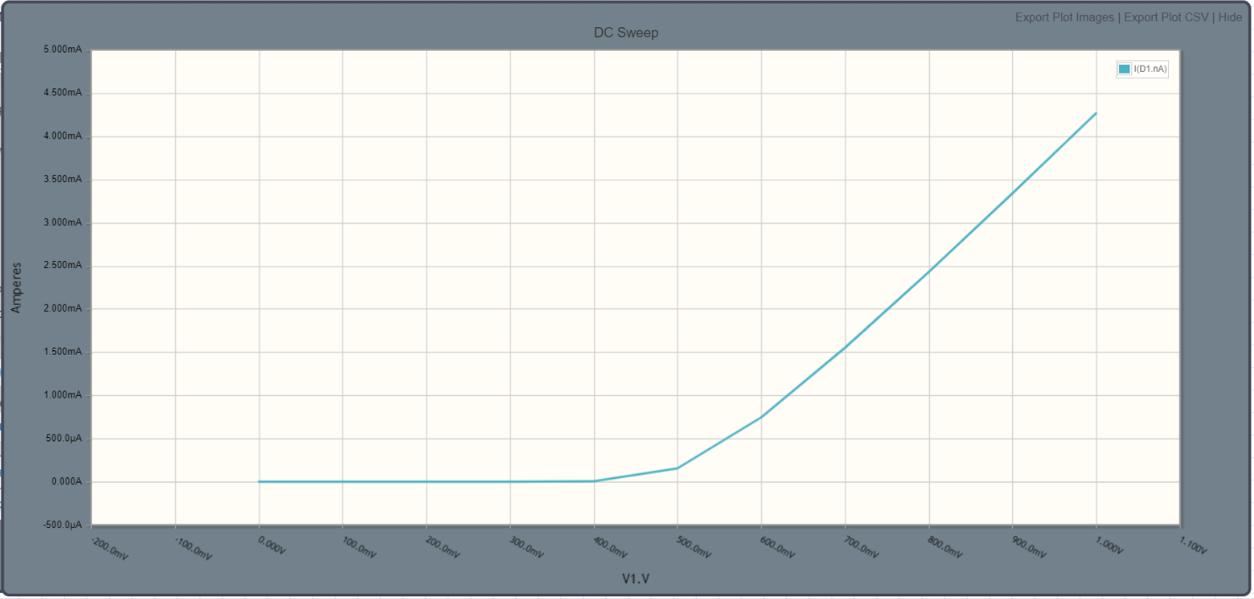

*3.) Explanation:*

*In Forward Bias, ZENER Diode Follows the Same I-V Characteristic Curve as Simple Diode in Forward Bias. Forward Voltage = 0.5 Volts*

B.) Reverse Characteristics of ZENER Diode

*1.) Circuit Image:*

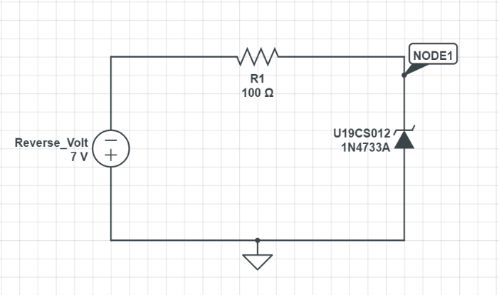

*2.) Graph:*

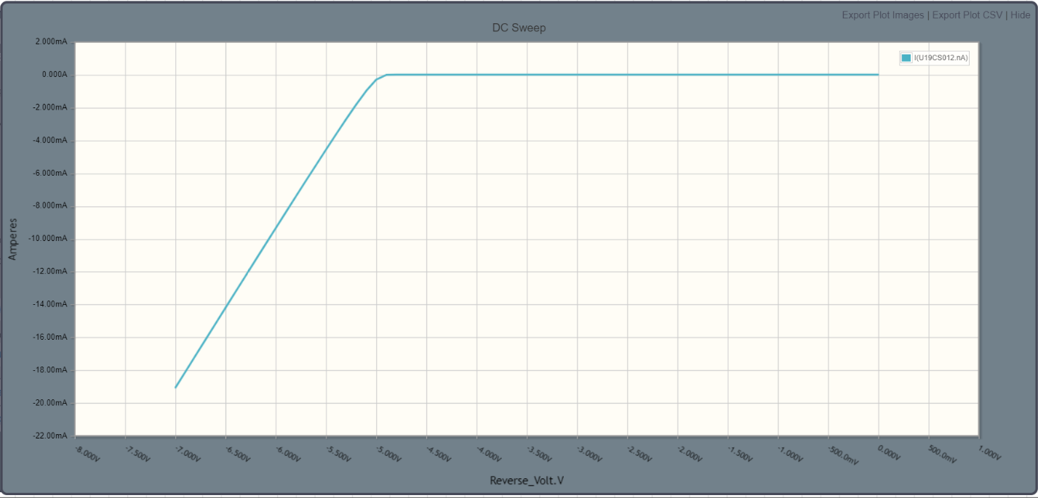

*3.) Explanation:*

In Reverse Bias, ZENER Diode Does not follows the Same I-V Characteristic Curve as Simple Diode in Reverse Bias, Instead a Sharp Drop in Current is observed. This is Called ZENER Breakdown Voltage.

Breakdown Voltage = -5 Volts

*C.) Conclusion:*

ZENER Diode I-V Characteristics have been Practically Verified through this Simulation with the Theoretical Knowledge. Hence Experiment was Performed Successfully. [Without Error]